**CHANDRIKA WOMEN AND YOUTH FOUNDATION**



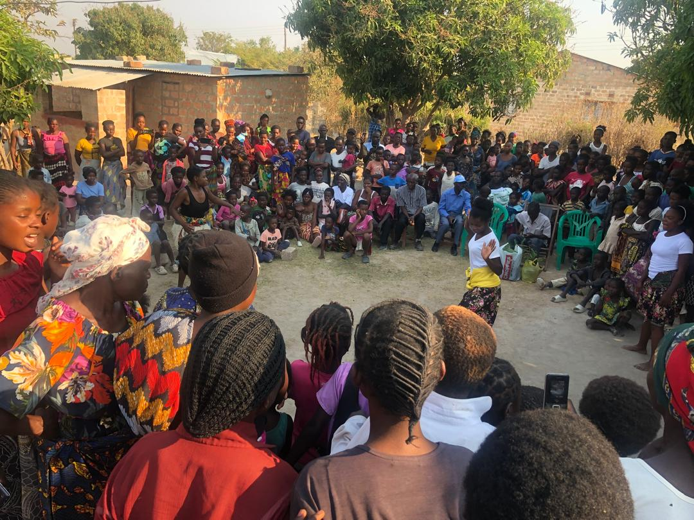

**REPORT ON COMMUNITY SENSITIZATION ON CLIMATE CHANGE IN NAMWANDWE WARD**

**Introduction**

This activity report is based on a Climate Change Community Sensitization organized by CWYF on the 5th of September in Namwandwe Ward of Mansa District. A total of 489 individuals were in attendance thus broken down as follows; 163 males and 326 females.

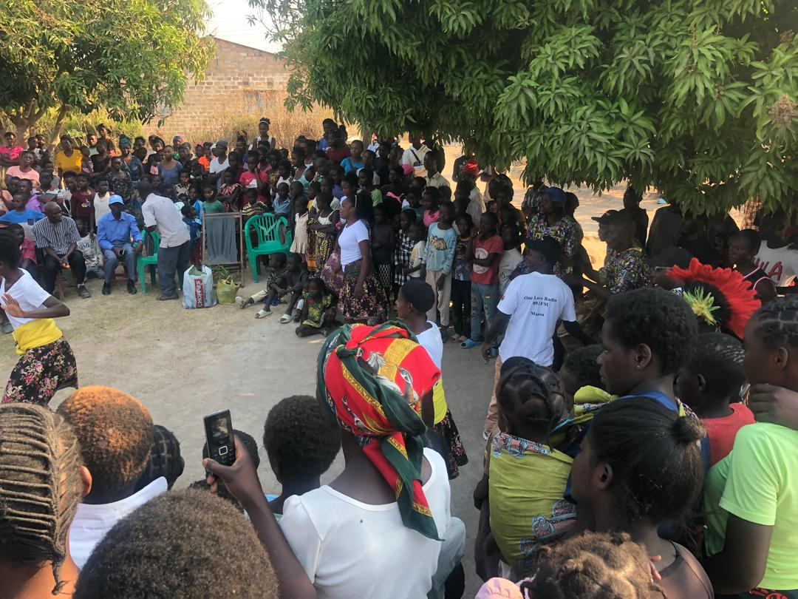***Part of the audience during the sensitization***

**Objective**

The event was aimed at creating awareness through sensitizations on issues of climate change in Namwandwe ward.

**Activities during the Event**

During the sensitization activity a diverse group of people were present, compressing of men, women, youths, and children, and these were entertained by dances from the drama group *Chili Kuli Iwe*. Who later performed a sketch on Climate Change, after the sketch one of the youthsstarted off by defining the term climate change, “Ukuchinga Kwa Michele” in bemba. He then proceeded to give a number of the causes and effects of Climate Change.

He further want on to explain that, “As Ba *Chili Kuli Iwe* practically demonstrated, cutting down of trees has become a common thing. This cutting down of trees is one of the many causes of climate change. To combat this, a tree should be planted. For each tree cut down, there should be a minimum of one tree planted to replace it.”

***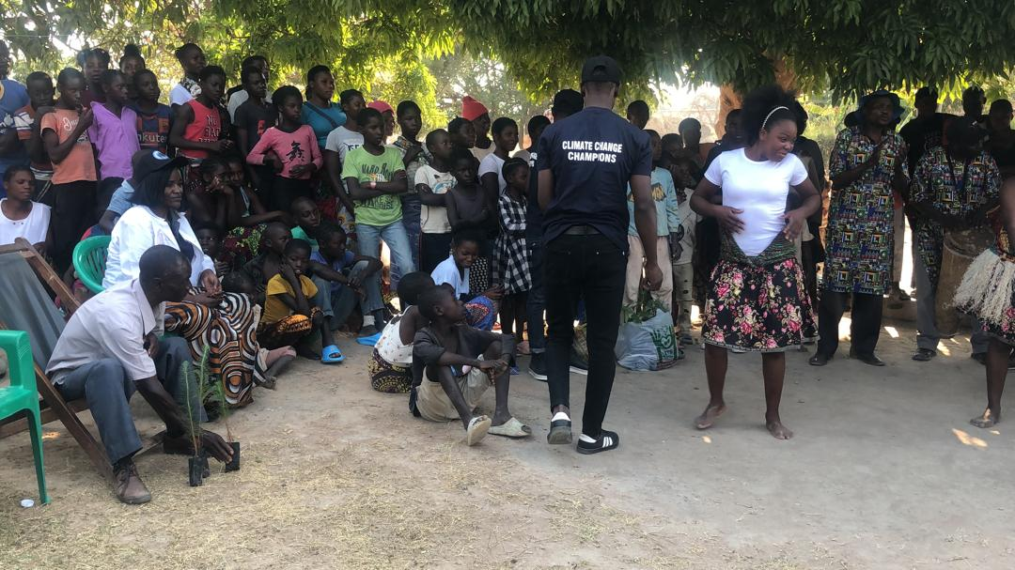******Members of Chili Kuli Iwe Drama Group entertaining the audience***

**Interactions with the Audience**

The floor was opened to the public and a number of questions poured in:

1. 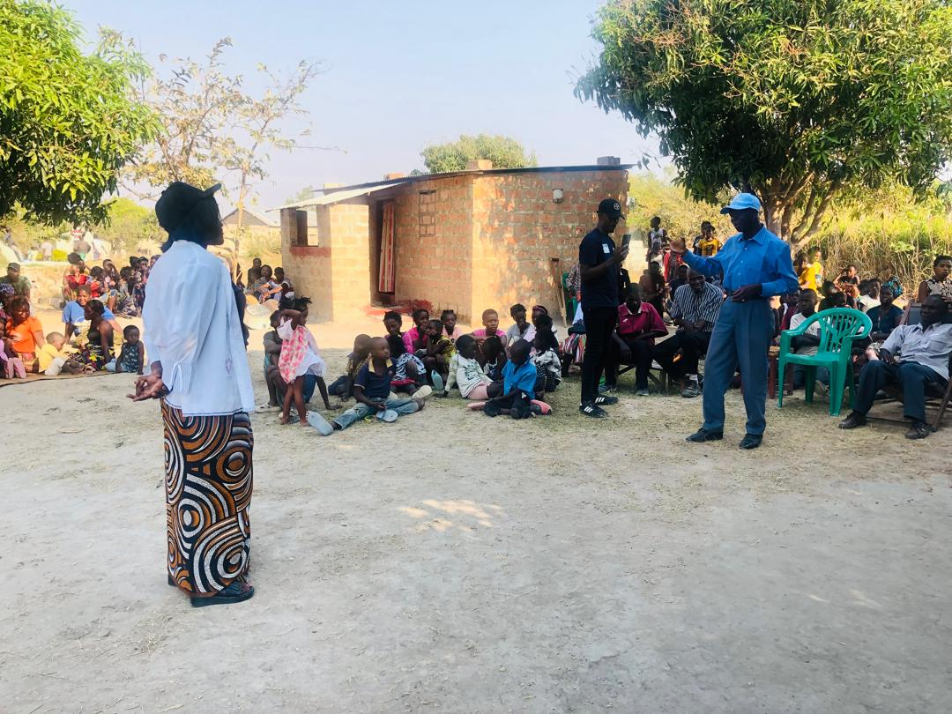**What is the importance of tree planting?**

***One of the participants posing a question***

* Carbon Capture: Trees absorb carbon dioxide from the atmosphere and store it, which helps reduce the greenhouse gases that contribute to global warming.
* Cooling Effect: Trees provide shade and release moisture into the air which can help lower temperatures.
* Water Regulation: Trees regulate the water cycle by absorbing rainwater and reducing runoff. This helps prevent flooding and maintains groundwater levels.
* Air Quality: Trees filter pollutants from the air, improving overall air quality.

1. **How do we fight deforestation?**

* Enforce Regulations: Implement and enforce laws that protect forests from illegal logging and land conversion.
* Reforestation and Afforestation: Plant trees in deforested areas and in places where forests didn’t previously exist to restore ecosystems.
* Encourage Agroforestry: Integrate trees into agricultural systems to provide benefits such as soil fertility, shade, and habitat for wildlife, while still allowing for productive farming.
* Raise Awareness: Educate the public about the importance of forests and the consequences of deforestation. Increased awareness can lead to more public support for conservation efforts.

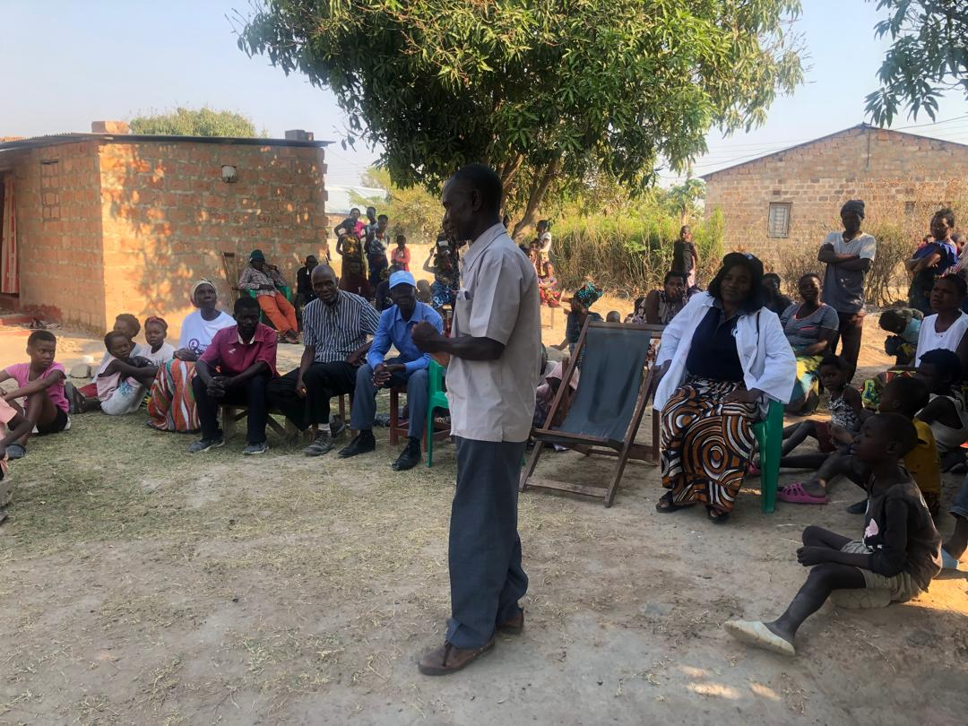***Village Headman Katumbi addressing his subjects during the event***

1. **Which trees can we plant during Climate Change?**

* Pines: resilient, adaptable, and drought-tolerant.
* Bamboo: fast-growing, carbon-absorbing, and adaptable.
* Acacia: Drought-tolerant, nitrogen-fixing, and carbon-efficient.
* Teak: Resilient, long-lived, and carbon-efficient.
* Eucalyptus: Fast-growing, drought-tolerant, and carbon-efficient.

These trees are good at capturing and storing carbon, however it’s important to consult local experts and visit Forestry offices to get your hands on these types of seedlings.

1. **What can we use to replace charcoal?**

* Cook stoves burn less fuel and produce less smoke compared to traditional charcoal stoves. These stoves use less charcoal or other fuels (eg. Wood pellets, dried ground nut shells), making them a more efficient option.

1. **How are you going to ensure that we don’t cut down trees?**

As we move forward, our dedicated Climate Change Champions will be keeping a watchful eye on our community's progress, but it's up to each of us to make a conscious choice to transform our ways and keep our promises.

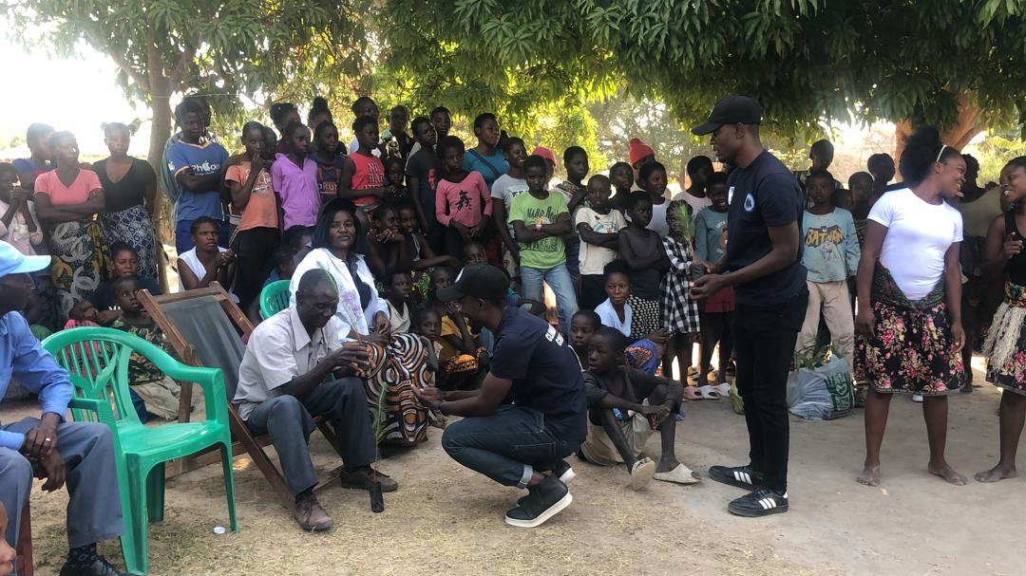**Tree Handover**

***Headman Katumbi receiving the plants during the tree handover***

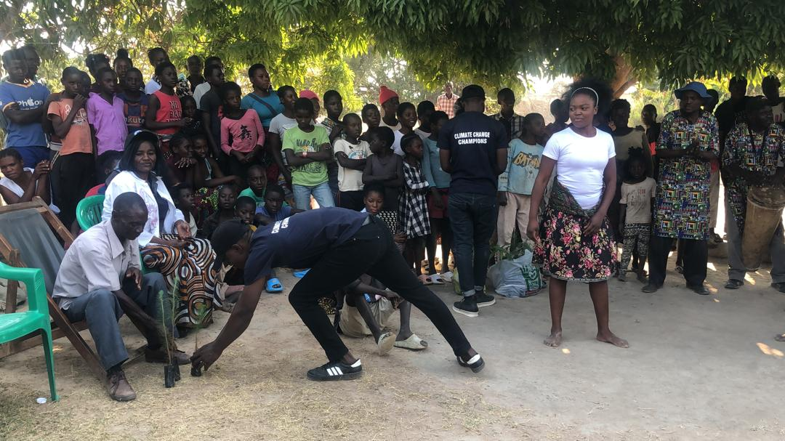

The Village Headman received 20 plants and was tasked with selecting 5 households in his community to receive them. Once the plants are planted by the household heads, they will be regularly monitored by 2 Climate Change Champions from Namwandwe Ward who will later on report to Chandrika Women and Youth Foundation.

**Interview of Two Namwandwe Community Members**

1. 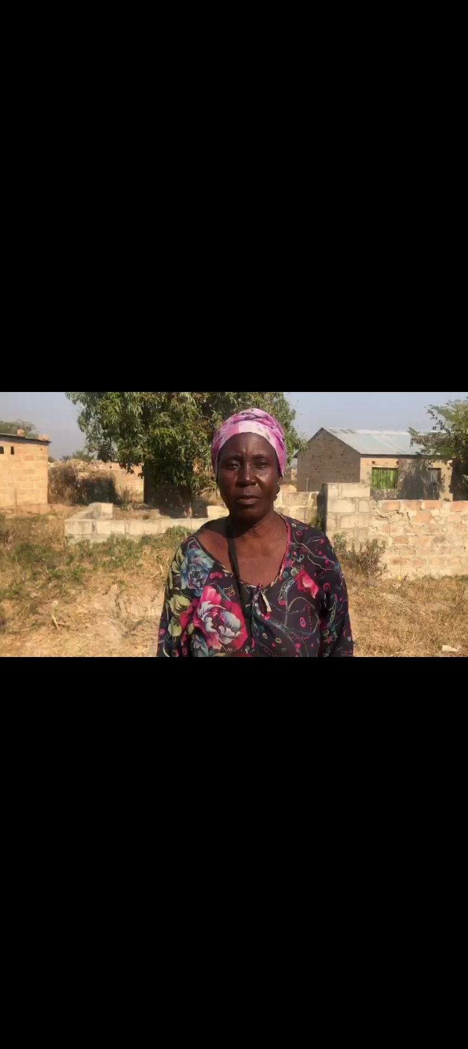**What are some of the benefits of keeping trees in the community?**

***One of the Community Members responding during the interview***

“Planting trees acts as a barrier, protecting houses from tumbling down on windy days. These same trees also provide food, like lemon trees, mango trees, and guava trees, all for the benefit of those staying on properties with trees. As an added bonus, lemon trees are medicine when one falls ill, providing a natural remedy right in your own yard.”

“Oranges and mangoes provide food and prevent hunger. It's not advised to just be sweeping a tree-less yard, even if you're in the deep bush. Those leaves that fall also play their role as fertilizer, so that seeds that fall there perchance can grow.”

“This is how the planet sustains its jungles and forests. But when humans come in and cut down trees, this process is interrupted.”

1. **Is there any wrong in people cutting down trees recklessly? (In communities and forests)**

“No shade means direct sun exposure, causing illnesses (eg. Skin cancer), fatigue and discomfort. No trees also means no free airflow, leading to stagnant air and respiratory issues.”

1. **Do you have any remarks that have to do with issues of climate change?**

***Headman Katumbi sharing his views during the interview***

"Let's apply what we've learnt from our climate change awareness program! We've seen how important trees are and how rain helps them thrive. If you must cut down trees, consider leaving the stumps to allow regrowth when it rains. I've always valued the benefits of keeping trees on my property and will continue to protect and preserve them for future generations."

**Conclusion**

The community's enthusiastic response to our climate change awareness program has been truly heartening. We are thrilled to see the impact of our efforts and are grateful for the appreciation shown to CWYF. This encouragement has energized us to continue spreading vital information and inspiring collective action on issues of Climate Change. We that by enhancing mitigation efforts, Luapula and Zambia at large can promote sustainable development and further build resilience to climate change impacts.